Title of your Research or Practice paper (style: Heading 1)
Aaaaa Xxxx (style: Author and Name), aaaaa@where.and.where (style: Author and Name + Not Bold, Italic)
University (style: Address)
Bbbbb Xxxx, bbbbb@there.and.there
University, try to fit it all in 1 line

Abstract (for Research/Practice Papers only, style: Abstract title)
For Research/Practice Papers, please add an extended one-page abstract here. Please use Normal style for the text. Include one picture in the abstract that best represents your work. Your title, abstract, picture, and keywords should use up the entire first page. If you do not need the whole page, leave the remaining space blank. The extended abstract must not proceed to the second page. Continue your paper contents on page two.
Please format pictures with style: Figure. Add a caption for each picture, formatted with Figure caption style. Please note that figure numeration starts in the regular chapters of your paper.
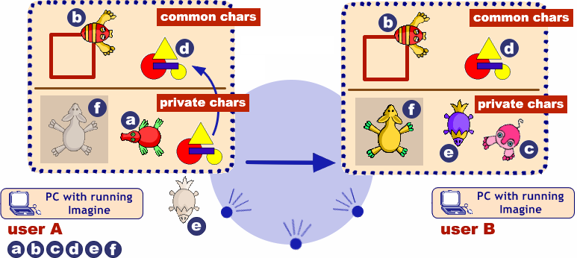
Sending and receiving common and private characters (style: Figure caption)
The quick brown fox jumps over the lazy dog. The quick brown fox jumps over the lazy dog. The quick brown fox jumps over the lazy dog. The quick brown fox jumps over the lazy dog. The quick brown fox jumps over the lazy dog. The quick brown fox jumps over the lazy dog. The quick brown fox jumps over the lazy dog. The quick brown fox jumps over the lazy dog. The quick brown fox jumps over the lazy dog. The quick brown fox jumps over the lazy dog. The quick brown fox jumps over the lazy dog.

Keywords (style: Keywords)
keyword; keyword or key phrase (style: Normal)

Abstract (style: Abstract title)
Please add an abstract of 100–150 words here. Use Normal style for the text.

Chapter (style: Heading 2)
Text of the chapter (style: Normal)
The quick brown fox jumps over the lazy dog. The quick brown fox jumps over the lazy dog. The quick brown fox jumps over the lazy dog. The quick brown fox jumps over the lazy dog. The quick brown fox jumps over the lazy dog. The quick brown fox jumps over the lazy dog. The quick brown fox jumps over the lazy dog. The quick brown fox jumps over the lazy dog. The quick brown fox jumps over the lazy dog.

Sub chapter (style: Heading 3)
The quick brown fox jumps over the lazy dog. The quick brown fox jumps over the lazy dog. The quick brown fox jumps over the lazy dog. The quick brown fox jumps over the lazy dog. The quick brown fox jumps over the lazy dog. The quick brown fox jumps over the lazy dog. The quick brown fox jumps over the lazy dog. The quick brown fox jumps over the lazy dog. The quick brown fox jumps over the lazy dog. The quick brown fox jumps over the lazy dog. The quick brown fox jumps over the lazy dog.
Please format pictures with style: Figure. Add a caption for each picture, formatted with Figure caption style.
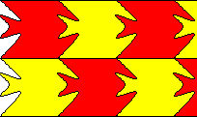
Figure 1. Tessellation (style: Figure caption)

Chapter

Sub chapter
The quick brown fox jumps over the lazy dog. The quick brown fox jumps over the lazy dog. The quick brown fox jumps over the lazy dog. The quick brown fox jumps over the lazy dog. The quick brown fox jumps over the lazy dog.
- the quick brown fox jumps over the lazy dog (style: bullet)
- the quick brown fox jumps over the lazy dog (style: bullet)
- the quick brown fox jumps over the lazy dog (style: bullet)
- the quick brown fox jumps over the lazy dog (style: bullet)

Conclusion and Discussion
The quick brown fox jumps over the lazy dog. The quick brown fox jumps over the lazy dog. The quick brown fox jumps over the lazy dog. The quick brown fox jumps over the lazy dog. The quick brown fox jumps over the lazy dog.

References (Please use the APA citation style)
Dagiene, V., Futschek, G. and Stupuriene, G. (2016) Developing computational thinking by using constructionist and deconstructionist learning. In Proceedings: Constructionism in Action 2016, February 1-5, Bangkok, Thailand. Bangkok: Suksapattana Foundation. p. 359-360.
Dagiene, V., Sentance, S., V. and Stupurienė, G. (2017) Developing a Two-Dimensional Categorization System for Educational Tasks in Informatics. Informatica, Vol. 28, No 1, p. 23-44.
Galik, Z. (2007) Contributions to the theory of order statistics. Ph.D. thesis, Comenius University, Bratislava.
Jones, A. B. and Smith, W. (1984) Statistical Methods for Scientists. Wiley, New York.
Kalas, I. and Winczer, M. (2007) Building interfaces for on-line collaborative learning. Journal of Environmental Science, 84, p. 161−175.
Salanci, L. (2001) Networking in Logo. In Proceedings: EuroLogo 2001. Edited by G. Futschek. Linz, August. p. 67−74.

